Operations Management, 10e, Global Edition (Heizer/Render)
Module C Transportation Models

1) The transportation model is an excellent tool for minimizing shipping costs among existing facilities, but it is not useful when firms consider new facility locations.
Answer: FALSE
Diff: 1
Topic: Transportation modeling
Objective: no LO

2) The transportation model seeks satisfactory, but not necessarily optimal, solutions for shipping goods from several origins to several destinations.
Answer: FALSE
Diff: 2
Topic: Transportation modeling
Objective: no LO

3) The transportation model is a special class of linear programming models.
Answer: TRUE
Diff: 1
Topic: Transportation modeling
Objective: no LO

4) A transportation problem requires exactly as many origins as destinations.
Answer: FALSE
Diff: 2
Topic: Transportation modeling
Objective: no LO

5) Neither the northwest corner rule nor the intuitive method considers shipping cost in making initial allocations.
Answer: FALSE
Diff: 2
Topic: Developing an initial solution
Objective: LO-Module C-1

6) The intuitive method of generating an initial solution has different results for each problem solver because "intuition" varies from person to person.
Answer: FALSE
Diff: 2
Topic: Developing an initial solution
Objective: LO-Module C-1

7) The stepping-stone method frequently achieves an optimal solution as soon as it calculates an initial feasible solution.
Answer: FALSE
Diff: 1
Topic: Developing an initial solution
Objective: LO-Module C-1
8) A feasible solution in transportation models is one in which all of the supply and demand constraints are satisfied.
Answer: TRUE
Diff: 2
Topic: Developing an initial solution
Objective: LO-Module C-1

9) The added cost of shipping one unit through an unused cell in a transportation problem without changing the edge requirements is the shipping cost associated with that cell.
Answer: FALSE
Diff: 2
Topic: The stepping-stone method
Objective: LO-Module C-2

10) In a transportation minimization problem, the negative improvement index associated with a cell indicates that reallocating units to that cell would lower costs.
Answer: TRUE
Diff: 2
Topic: The stepping-stone method
Objective: LO-Module C-2

11) Degeneracy in a transportation problem is when no closed path exists for evaluating an unused cell.
Answer: TRUE
Diff: 2
Topic: Special issues in modeling
Objective: LO-Module C-4

12) When using the stepping stone method, the closed path sometimes has the shape of a triangle as diagonal moves are permitted.
Answer: FALSE
Diff: 2
Topic: The stepping-stone method
Objective: LO-Module C-2

13) When using the stepping stone method for a minimization problem, the number of units that reallocates corresponds to the smallest number found in the cells containing minus signs.
Answer: TRUE
Diff: 2
Topic: The stepping-stone method
Objective: LO-Module C-2

14) A transportation problem with a total supply of 500 and a total demand of 400 will have an optimal solution that leaves 100 units of supply unused.
Answer: TRUE
Diff: 2
Topic: Special issues in modeling
Objective: LO-Module C-3
15) A transportation problem with 8 sources and 6 destinations will have an optimal solution that uses at most 13 of the 48 possible routes.
Answer: TRUE
Diff: 2
Topic: Special issues in modeling
AACSB: Analytic Skills
Objective: LO-Module C-4

16) To handle degeneracy, a very small quantity is placed in one of the unused squares.
Answer: TRUE
Diff: 2
Topic: Special issues in modeling
Objective: LO-Module C-4

17) Degeneracy occurs when the number of occupied squares is less than the number of rows plus the number of columns minus one.
Answer: TRUE
Diff: 2
Topic: Special issues in modeling
Objective: LO-Module C-4

18) If demand exceeds supply in a transportation problem, the problem must be balanced by adding a dummy source with additional supply.
Answer: TRUE
Diff: 2
Topic: Special issues in modeling
Objective: LO-Module C-3

19) Which of the following is not needed in order to use the transportation model?
A) the source points and their capacity
B) the fixed costs of source points
C) the destination points and their demand
D) the cost of shipping one unit from each source to each destination
E) All of these are needed.
Answer: B
Diff: 1
Topic: Transportation modeling
Objective: no LO

20) The information needs of a transportation problem include
A) the cost of shipping one unit from each origin to each destination
B) the set of destinations and the demand of each
C) the set of origins
D) the supply at each origin
E) all of the above
Answer: E
Diff: 1
Topic: Transportation modeling
Objective: no LO
21) Which of the following is not information needed for a transportation problem?
A) the cost of shipping one unit from each origin to each destination
B) the set of destinations and the demand at each
C) the set of origins and the demand at each origin
D) the list of sources and the capacity at each
E) None of the above is needed.
Answer: C
Diff: 1
Topic: Transportation modeling
Objective: no LO

22) The purpose of the transportation approach for location analysis is to minimize
A) total costs
B) total variable costs
C) total fixed costs
D) total shipping costs
E) the number of shipments
Answer: D
Diff: 2
Topic: Transportation modeling
Objective: no LO

23) The transportation method is a special case of the family of problems known as
A) regression problems
B) decision tree problems
C) linear programming problems
D) simulation problems
E) statistical problems
Answer: C
Diff: 1
Topic: Transportation modeling
Objective: no LO

24) Transportation modeling is best applied when which of the following conditions are met?
A) 1+ source and 2+ destinations
B) 2+ sources and 2+ destinations
C) 1+ source and 1+ destination
D) 2+ sources and 1+ destination
E) Transportation modeling is useful under any of the above conditions.
Answer: D
Diff: 2
Topic: Transportation modeling
Objective: no LO
25) The initial solution to a transportation problem can be generated several ways, so long as
A) it minimizes cost
B) it ignores cost
C) all supply and demand conditions are satisfied
D) degeneracy does not exist
E) all cells are filled
Answer: C
Diff: 2
Topic: Developing an initial solution
Objective: LO-Module C-1

26) The northwest-corner rule is best used
A) to minimize the total shipping cost from several origins to several destinations
B) to calculate whether a feasible solution is also an optimal solution
C) to calculate how much to transfer from one shipping route to another
D) to generate an initial feasible solution to a transportation problem
E) to resolve cases of degeneracy in transportation problems
Answer: D
Diff: 1
Topic: Developing an initial solution
Objective: LO-Module C-1

27) For the problem data set below, what is the northwest corner allocation to the cell Source 1-Destination 1?

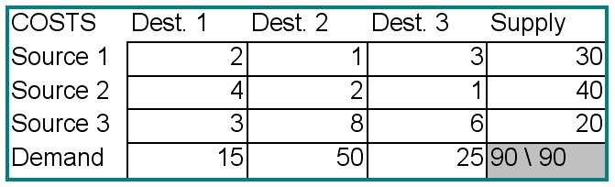
A) 0
B) 2
C) 15
D) 90
Answer: C
Diff: 1
Topic: Developing an initial solution
AACSB: Analytic Skills
Objective: LO-Module C-1
28) For the problem data set below, what is the northwest corner allocation to the cell Source 1 -Destination 2?

A) 0
B) 15
C) 25
D) 45
Answer: B
Diff: 2
Topic: Developing an initial solution
AACSB: Analytic Skills
Objective: LO-Module C-1

29) For the problem data set below, what is the northwest corner allocation to the cell Source 3-Destination 3?

A) 0
B) 15
C) 20
D) 35
E) 45
Answer: C
Diff: 2
Topic: Developing an initial solution
AACSB: Analytic Skills
Objective: LO-Module C-1

30) The Northwest-Corner rule's biggest flaw is that
A) it ignores costs
B) it cannot generate feasible solutions
C) it never generates ideal solutions
D) it ignores shipping time
E) There are no major flaws.
Answer: A
Diff: 2
Topic: Developing an initial solution
Objective: LO-Module C-1
31) For the problem below, what is the quantity assigned to the cell Source 1-Destination 2 using the intuitive method for an initial feasible solution?

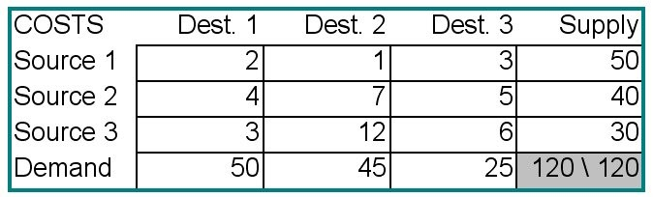
A) 1
B) 5
C) 30
D) 45
E) 50
Answer: D
Diff: 2
Topic: Developing an initial solution
AACSB: Analytic Skills
Objective: LO-Module C-1

32) For the problem below, what is the quantity assigned to the cell Source 3-Destination 1 using the intuitive method for an initial feasible solution?

A) 3
B) 13.333
C) 30
D) 45
E) 50
Answer: C
Diff: 1
Topic: Developing an initial solution
AACSB: Analytic Skills
Objective: LO-Module C-1
33) The main difference between the intuitive lowest-cost method and the Northwest-corner rule is that
A) the intuitive lowest-cost method always generates a better solution
B) the Northwest-corner rule is faster
C) the Northwest-corner rule ignores cost
D) only the intuitive lowest-cost method generates an optimal solution
E) None of the above are accurate.
Answer: C
Diff: 2
Topic: Developing an initial solution
Objective: LO-Module C-1
34) A transportation problem has a feasible solution when
A) all of the improvement indices are greater than or equal to zero
B) all demand and supply constraints are satisfied
C) the number of filled cells is one less than the number of rows plus the number of columns
D) all the squares are used
E) the solution yields the lowest possible cost
Answer: B
Diff: 2
Topic: The stepping-stone method
Objective: LO-Module C-2

35) A transportation problem has an optimal solution when
A) all of the improvement indices are greater than or equal to zero
B) all demand and supply constraints are satisfied
C) the number of filled cells is one less than the number of rows plus the number of columns
D) all the squares are used
E) all origin-destination combinations have been made equally low in cost
Answer: A
Diff: 2
Topic: The stepping-stone method
Objective: LO-Module C-2

36) In transportation model analysis the stepping-stone method is used to
A) obtain an initial optimum solution
B) obtain an initial feasible solution
C) evaluate empty cells for possible degeneracy
D) balance supply and demand
E) evaluate empty cells for potential solution improvements
Answer: E
Diff: 1
Topic: The stepping-stone method
Objective: LO-Module C-2
37) The total cost of the optimal solution to a transportation problem
A) is calculated by multiplying the total supply (including any dummy values) by the average cost
of the cells
B) cannot be calculated from the information given
C) can be calculated based only on the entries in the filled cells of the solution
D) can be calculated from the original northwest corner solution
E) is found by multiplying the amounts in each cell by the cost for that cell for each row and then subtracting the products of the amounts in each cell times the cost of each cell for the columns
Answer: C
Diff: 2
Topic: The stepping-stone method
Objective: LO-Module C-2

38) Consider the transportation problem and its optimal solution in the tables below. What is the value of the objective function?

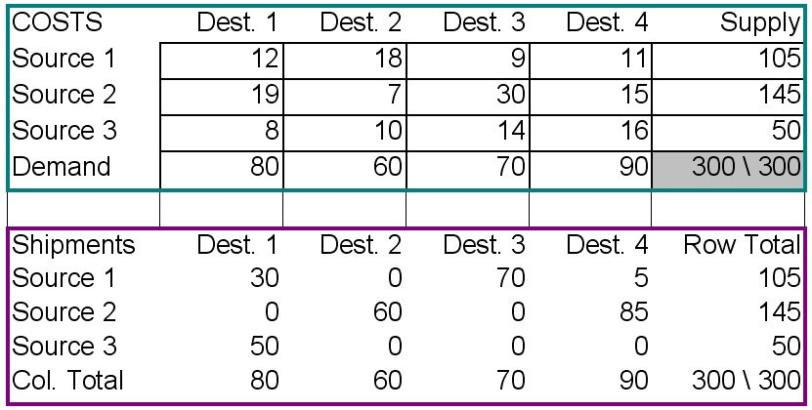
A) 0
B) $169
C) 300 units
D) $2,100
E) $3,140
Answer: E
Diff: 2
Topic: The stepping-stone method
AACSB: Analytic Skills
Objective: LO-Module C-2
39) Consider the transportation problem and its optimal solution in the tables below. The cell Source 3 — Destination 3 is currently empty. What would be the change in the objective function if the largest possible amount were shipped using that route, leaving all the supply and demand conditions unchanged?

A) 0
B) fifty units
C) a decrease of $9
D) an increase of $450
E) an increase of $630
Answer: D
Diff: 3
Topic: The stepping-stone method
AACSB: Analytic Skills
Objective: LO-Module C-2

40) In a minimization problem, a negative improvement index in a cell indicates that the
A) solution is optimal
B) total cost will increase if units are reallocated to that cell
C) current iteration is worse than the previous one
D) total cost will decrease if units are reallocated to that cell
E) problem has no feasible solution
Answer: D
Diff: 2
Topic: The stepping-stone method
Objective: LO-Module C-2

41) In a minimization problem, a positive improvement index in a cell indicates that
A) the solution is optimal
B) the total cost will increase if units are reallocated to that cell
C) there is degeneracy
D) the total cost will decrease if units are reallocated to that cell
E) the problem has no feasible solution
Answer: B
Diff: 2
Topic: The stepping-stone method
Objective: LO-Module C-2
42) Consider the transportation problem and its initial solution in the table below. What is the improvement index for the empty cell Source 1 — Destination 3?

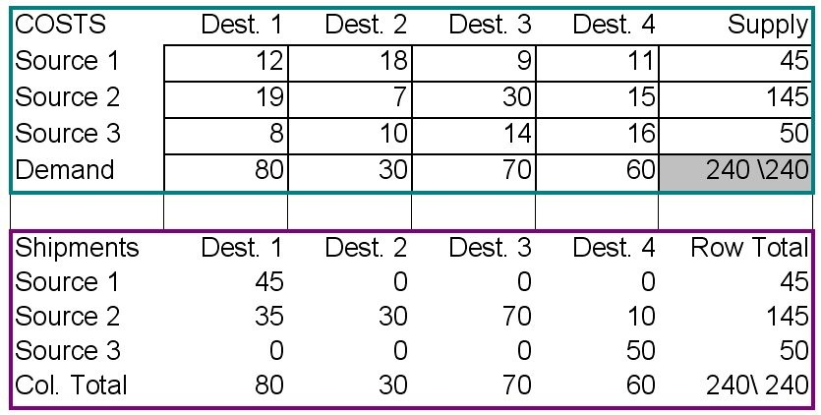
A) 0
B) -14
C) -23
D) -70
E) 115
Answer: B
Diff: 2
Topic: The stepping-stone method
AACSB: Analytic Skills
Objective: LO-Module C-2

43) The stepping-stone method
A) is an alternative to using the northwest-corner rule
B) often involves tracing closed paths with a triangular shape
C) is used to identify the relevant costs in a transportation problem
D) is used to evaluate the cost effectiveness of shipping goods via transportation routes not currently in the solution
E) helps determine whether a solution is feasible or not
Answer: D
Diff: 2
Topic: The stepping-stone method
Objective: LO-Module C-2

44) One difference between the stepping-stone method compared to the Northwest-corner and intuitive method is that
A) the stepping-stone method never finds a feasible solution
B) the stepping-stone method ignores costs
C) the stepping-stone method ALWAYS finds a lower-cost solution
D) the stepping-stone method guarantees an optimal solution
E) All of the above or None of the above.
Answer: D
Diff: 2
Topic: The stepping-stone method
Objective: LO-Module C-1 and LO2
45) A transportation problem has improvement indices of 5, 4, 0, and -3. Which of the following is always true?
A) The transportation model is at its ideal solution.
B) The transportation model is at a feasible solution.
C) The total cost saved by changing one unit on the route with an improvement index of 5 would be $5.
D) The transportation matrix has four empty squares.
E) Both B and D
Answer: E
Diff: 2
Topic: The stepping-stone method
Objective: LO-Module C-2

46) An improvement index indicates
A) whether a method other than the stepping-stone should be used
B) whether a method other than the northwest-corner rule should be used
C) how much total cost would increase or decrease if a single unit was reallocated to that cell
D) whether the transportation cost in the upper left-hand corner of a cell is optimal
E) how much total cost would increase or decrease if the largest possible quantity were reallocated to that cell
Answer: C
Diff: 2
Topic: The stepping-stone method
Objective: LO-Module C-2

47) A transportation problem has two origins: A can supply 20 units and B can supply 30 units. This problem has two destinations: C requires 25 units and D requires 35 units. Which of the following is true?
A) The problem will require a dummy demand with a capacity of 10 units.
B) The problem is unbalanced and cannot be solved by the transportation method.
C) The problem will require a dummy supply with a capacity of 10 units.
D) Destinations C and D must each receive 5 units less than they require.
E) None of the above is true.
Answer: C
Diff: 1
Topic: Special issues in modeling
Objective: LO-Module C-3

48) When the number of shipments in a feasible solution is less than the number of rows plus the number of columns minus one
A) the solution is optimal
B) a dummy source must be created
C) a dummy destination must be created
D) there is degeneracy, and an artificial allocation must be created
E) the closed path has a triangular shape
Answer: D
Diff: 2
Topic: Special issues in modeling
Objective: LO-Module C-4
49) In a transportation problem, degeneracy means that
A) the problem was improperly constructed, and must be reformulated
B) the assumptions of the transportation model have not been met
C) the number of filled cells is too small to allow the calculation of improvement indices
D) the total supply and the total demand are unbalanced
E) he number of origins is not equal to the number of destinations
Answer: C
Diff: 1
Topic: Special issues in modeling
Objective: LO-Module C-4

50) A transportation problem has 8 origins and 6 destinations. The optimal solution of this problem will fill no more than __________ cells with quantities to be shipped.
A) 2
B) 13
C) 14
D) 48
E) cannot be calculated without knowing the supply and demand totals
Answer: B
Diff: 1
Topic: Special issues in modeling
AACSB: Analytic Skills
Objective: LO-Module C-3

51) A transportation problem has 4 origins and 2 destinations. The optimal solution of this problem will fill no more than __________ cells with quantities to be shipped.
A) 5
B) 6
C) 8
D) 20
E) All cells will be occupied.
Answer: A
Diff: 1
Topic: Special issues in modeling
AACSB: Analytic Skills
Objective: LO-Module C-3

52) A large transportation problem has 220 origins and 1360 destinations. The optimal solution of this problem will fill no more than about __________ of cells with quantities to be shipped.
A) one-half of one percent
B) five percent
C) ten percent
D) twenty-five
E) All cells will be occupied.
Answer: A
Diff: 2
Topic: Special issues in modeling
AACSB: Analytic Skills
Objective: LO-Module C-3
53) Total demand for a transportation model is 15 while total supply is 20. Which of the following should be included?
A) a dummy source of 20 units
B) a dummy destination of 5 units
C) a dummy source of 5 units
D) a dummy destination of 20 units
E) none of the above
Answer: B
Diff: 2
Topic: Special issues in modeling
Objective: LO-Module C-3

54) Suppose the solution for a transportation model fills 5 cells with quantities to be shipped. Which of the following combinations of sources and destinations would be degenerate?
A) 2 sources, 4 destinations
B) 3 sources, 3 destinations
C) 4 sources, 2 destinations
D) 5 sources, 1 destination
E) None of the above are degenerate.
Answer: E
Diff: 2
Topic: Special issues in modeling
Objective: LO-Module C-4

55) A transportation model fills one half of its cell under the optimal solution. Which of the following most closely describes the number of sources compared to the number of destinations?
A) 1 to 1
B) 2 to 2
C) 3 to 3
D) 4 to 3
E) 4 to 4
Answer: D
Diff: 2
Topic: Special issues in modeling
Objective: LO-Module C-4

56) Which of the following combinations of sources and destinations would fill no more than 25% of cells with quantities to be shipped for the optimal solution?
A) 1 to 1
B) 1 to 4
C) 4 to 1
D) 8 to 2
E) 5 to 16
Answer: E
Diff: 2
Topic: Special issues in modeling
Objective: LO-Module C-4
57) Which of the following is true for degenerate problems?
A) They do not contain a feasible solution.
B) They do not contain an optimal solution.
C) Supply is greater than demand.
D) Demand is greater than supply.
E) None of the above
Answer: E
Diff: 2
Topic: Special issues in modeling
Objective: LO-Module C-4

58) The elements of a transportation problem that supply goods are referred to as __________.
Answer: origins, origin points, or sources
Diff: 1
Topic: Transportation modeling
Objective: no LO

59) The __________ finds the least-cost means of shipping supplies from several origins to several destinations.
Answer: transportation model
Diff: 1
Topic: Transportation modeling
Objective: no LO

60) The three information needs of a transportation problem are the origin points and the capacity at each, the destination points and the demand at each, and __________.
Answer: the cost of shipping one unit from each origin to each destination
Diff: 2
Topic: Transportation modeling
Objective: no LO

61) The __________ develops an initial feasible solution for a transportation model by starting at the upper left-hand cell of a table and systematically allocating units to shipping points.
Answer: northwest-corner rule
Diff: 2
Topic: Developing an initial solution
Objective: LO-Module C-1

62) The __________ is an iterative technique for moving from an initial feasible solution to an optimal solution in the transportation method.
Answer: stepping-stone method
Diff: 2
Topic: The stepping-stone method
Objective: LO-Module C-2
63) A transportation problem that has more units supplied than demanded will require a(n) __________ to balance the problem.
Answer: dummy destination
Diff: 2
Topic: Special issues in modeling
Objective: LO-Module C-3

64) __________ is an occurrence in transportation problems when too few shipping routes are being used to allow calculation of improvement indices.
Answer: Degeneracy
Diff: 2
Topic: Special issues in modeling
Objective: LO-Module C-4

65) The number of routes filled by a solution to a transportation problem is no larger than __________.
Answer: the sum of columns plus rows minus one
Diff: 2
Topic: Special issues in modeling
Objective: LO-Module C-3

66) What is transportation modeling?
Answer: Transportation modeling finds the least-cost means of shipping supplies from several origins to several destinations.
Diff: 1
Topic: Transportation modeling
Objective: no LO

67) State, in order, the three steps in making an initial allocation with the northwest-corner rule.
Answer: The three steps in making an initial allocation using the northwest-corner rule are: exhaust the supply of each row before moving down to the next row; exhaust the demand requirements of each column before moving to the next column on the right; and check that all supply and demand constraints are met.
Diff: 2
Topic: Developing an initial solution
Objective: LO-Module C-1

68) What purpose does the northwest-corner rule serve?
Answer: The northwest-corner is a procedure used with the transportation model that starts in the upper left-hand cell and systematically allocates units to shipping routes. Its purpose is to generate an initial feasible solution.
Diff: 1
Topic: Developing an initial solution
Objective: LO-Module C-1
69) What does the stepping-stone method do?
Answer: The stepping-stone method is an interactive technique for moving from an initial feasible solution to an optimal solution in the transportation model.
Diff: 2
Topic: The stepping-stone method
Objective: LO-Module C-2
70) What is the difference between a feasible solution and an optimal solution?
Answer: A feasible solution, like in linear programming, is a possible problem solution that does not violate any constraints. It may or may not be optimal. The optimal solution is the answer that provides the lowest total cost or highest total profit.
Diff: 2
Topic: The stepping-stone method
Objective: LO-Module C-2

71) When does degeneracy occur in a transportation model?
Answer: Degeneracy occurs when the number of occupied cells is less than the number of rows plus the number of columns minus one.
Diff: 2
Topic: Special issues in modeling, moderate
Objective: LO-Module C-4

72) When is it necessary to add dummy sources or destinations to a transportation problem?
Answer: It is necessary to add dummy sources when the total demand is greater than the total supply. A dummy destination would be required when total supply exceeds total demand.
Diff: 2
Topic: Special issues in modeling
Objective: LO-Module C-4

73) The larger a transportation problem (that is, as the problem has more rows and more columns), the smaller the fraction of all possible routes that will be filled in a solved problem. Explain.
Answer: The number of filled cells in a solved transportation problem is rows plus columns minus one. For a problem with three origins and four destinations, the number of filled cells will be no more than 3 + 4 -1 = 6, which is 6/12 or one-half of all 3*4 = 12 possible routes. If a problem has six origins and eight destinations, the number of filled cells will be no more than 6 + 8 — 1 = 13, which is 13/48 of all 6*8 = 48 possible routes. There are four times as many routes, but the number of filled cells barely doubles. In general, (R + C - 1) / R*C falls as R and/or C rise.

Diff: 2
Topic: Special issues in modeling
AACSB: Analytic Skills
Objective: LO-Module C-3
74) In formulating a transportation problem, you discover that one of the route combinations is forbidden by contract, or prohibited by law, or ruled out by company policy. How would you indicate the cost of that cell in preparing the problem to be solved?
Answer: The easiest way to "prohibit" a route is to assign it a cost sufficiently high that it simply won't be used in the optimal solution. It is not possible to give that cell a non-numeric cost in most software applications, and it is wrong to give it a zero cost (which would make it free, not prohibited).
Diff: 2
Topic: Special issues in modeling
Objective: LO-Module C-3

75) How might the transportation method be used to help a firm add a facility to an existing distribution network? You may wish to describe a simple example.
Answer: Assume that the existing network has two sources S1 and S2 and two destinations D1 and D2, and that the firm needs more supply and is going to build a third supply point. Also assume that the firm has found two competing sites for the third facility New1 and New2. The firm must determine the shipping costs from New1 and New2 to D1 and to D2. Then the firm must solve two transportation problems. One will have three suppliers, S1, S2, and New1. The other will have three suppliers S1, S2, and New2. The cheaper total cost result indicates the preferred new facility location. It is not appropriate to solve one problem with New1 and New2 as the third and fourth supply points.
Diff: 2
Topic: Special issues in modeling
AACSB: Reflective Thinking
Objective: LO-Module C-3

76) A transportation problem has 6 origins and 12 destinations. How many possible routes are there for this problem? How many routes will be used in the optimal solution?
Answer: The number of possible routes is origins times destinations, or 6 * 12 = 72. The number of filled cells (routes used) in the solution is no more than origins plus destinations minus one, or 6 + 12 — 1 = 17.
Diff: 1
Topic: Special issues in modeling
AACSB: Analytic Skills
Objective: LO-Module C-3

77) A transportation problem has 10 origins and 32 destinations. How many possible routes are there for this problem? How many routes will be used in the optimal solution?
Answer: The number of possible routes is origins times destinations, or 10 * 32 = 320. The number of filled cells (routes used) in the solution is no more than origins plus destinations minus one, or 10 + 32 — 1 = 41.
Diff: 1
Topic: Special issues in modeling
AACSB: Analytic Skills
Objective: LO-Module C-3
78) For the data below, construct an initial feasible solution using the northwest-corner rule.

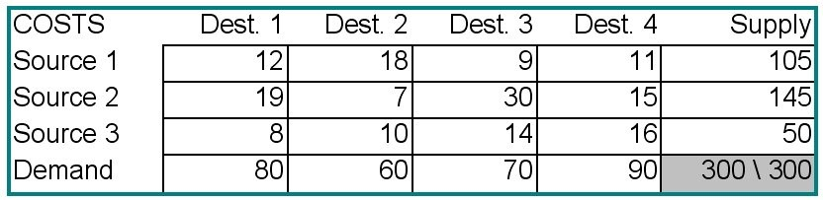
Answer: Step 1: The smaller value at the intersection of S1 and D1 is 80. Assign 80 to S1D1, and rule out other cells in D1. The smaller value at the intersection of S1 and D2 is 25 (105-80); assign 25 to S1D2 and rule out other cells in S1. The smaller value at the intersection of S2 and D2 is 35 (60-25); assign 35 to S2D2 and rule out other cells in D2. The smaller value at the intersection of S2 and D3 is 70; assign 70 to S2D3 and rule out other cells in D3. The remaining assignments are 40 at S2D4 and 50 at S3D4. These actions are summarized in the table below.

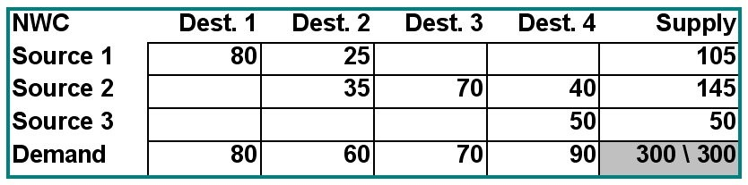
Diff: 2
Topic: Developing an initial solution
AACSB: Analytic Skills
Objective: LO-Module C-1
79) For the transportation problem below, construct an initial feasible solution using the intuitive method.

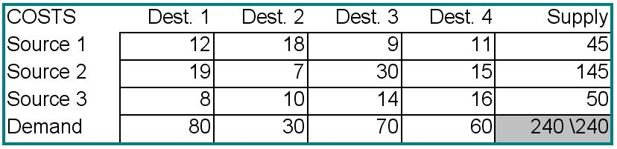
Answer: The lowest cost in the matrix is 7; assign 30 units to S2D2 and rule out all other cells in D2. Now the lowest cost in the table is 8; assign 50 units to S3D1 and rule out all other cells in S3. The smallest cost is now 9; assign 45 units to S1D3 and rule out all other S1. The remaining assignments are 60 units to S2D4, 30 units to S2D1, and 25 units to S2D3. These assignments are summarized in the table below.

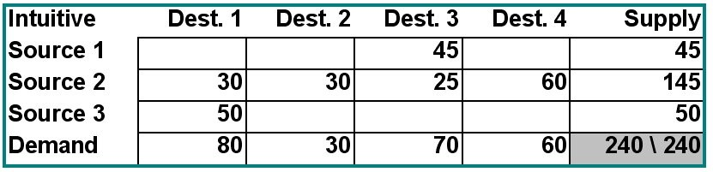
Diff: 2
Topic: Developing an initial solution
AACSB: Analytic Skills
Objective: LO-Module C-1

80) Consider the transportation problem in the data set and optimal solution below. Verify by hand or by calculator (show your work) the value of the objective function.

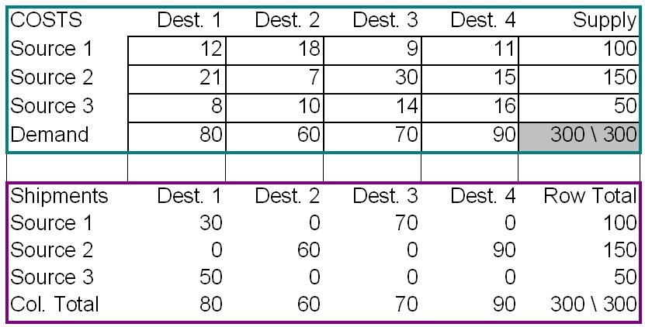
Answer: The objective is $12 *30 + $9*70 + $ 7*60 + $15*90 +$8*50 = $3,160
Diff: 1
Topic: The stepping-stone method
AACSB: Analytic Skills
Objective: LO-Module C-2
81) Consider the transportation problem in the data set and optimal solution below.
Calculate improvement indices on each empty cell. Is this solution optimal?

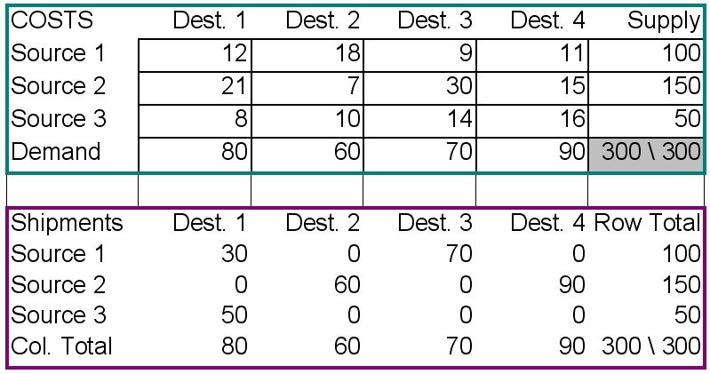
Answer: The solution is optimal.
Diff: 2
Topic: The stepping-stone method
AACSB: Analytic Skills
Objective: LO-Module C-2

82) Find the minimum cost shipping solution for the transportation problem data set in the table below. Provide a table of shipping quantities and the minimum value for the objective function.

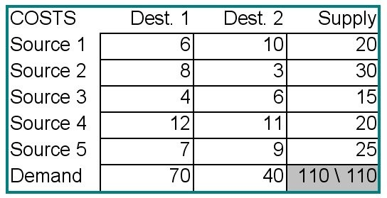
Answer: (a) The optimal solution is shown in the solution below. (b) The minimum cost is $675.

Shipments | Dest. 1 | Dest. 2 | Row Total
Source 1 | 20 | 0 | 20
Source 2 | 0 | 30 | 30
Source 3 | 15 | 0 | 15
Source 4 | 10 | 10 | 20
Source 5 | 25 | 0 | 25
Col. Total | 70 | 40 | 110 \ 110
Total Cost | 675

Diff: 2
Topic: The stepping-stone method
AACSB: Analytic Skills
Objective: LO-Module C-2
83) Consider the transportation data set for a minimization problem below.

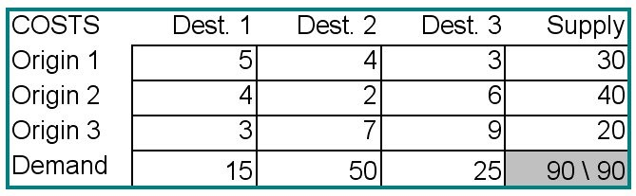
a. Calculate the initial solution using the northwest-corner rule.
b. Calculate improvement indices, iterate, and solve for the optimal shipping pattern.
Answer: The initial solution and improvement indices appear in the first table below. The optimal solution appears in the second table.

NWC | Dest. 1 | Dest. 2 | Dest. 3 | Row Total
Origin 1 | Ship 15 | Ship 15 | Save 5 | 30
Origin 2 | Add 1 | Ship 35 | Ship 5 | 40
Origin 3 | Save 3 | Add 2 | Ship 20 | 20
Col. Total | 15 | 50 | 25 | 90 \ 90
Shipments | Dest. 1 | Dest. 2 | Dest. 3 | Row Total
Origin 1 | 0 | 5 | 25 | 30
Origin 2 | 0 | 40 | 0 | 40
Origin 3 | 15 | 5 | 0 | 20
Col. Total | 15 | 50 | 25 | 90 \ 90
Total Cost | $255

Diff: 2
Topic: The stepping-stone method
AACSB: Analytic Skills
Objective: LO-Module C-2
84) Find the minimum cost solution for the transportation problem detailed in the table below. Explain carefully the meaning of any quantity in a "dummy" row or column.

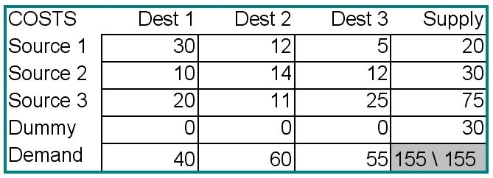
Answer: The optimum solution, which costs $1370, appears in the solution below. A dummy source row was added since total supply was less than total demand. Thirty units are shipped from Dummy to Destination 3. This means that Destination 3 does not receive 30 units that it demanded. The dummy row can be interpreted as unfilled demand, or shortfall.

Shipments | Dest 1 | Dest 2 | Dest 3 | Row Total
Source 1 | 0 | 0 | 20 | 20
Source 2 | 25 | 0 | 5 | 30
Source 3 | 15 | 60 | 0 | 75
Dummy | 0 | 0 | 30 | 30
Col. Total | 40 | 60 | 55 | 155 \ 155
Total Cost | $1370

Diff: 2
Topic: The stepping-stone method
AACSB: Analytic Skills
Objective: LO-Module C-2
85) The Shamrock Transportation Company has four terminals: A, B, C, and D. At the start of a particular day, there are 8, 8, 6, and 3 tractors available at those terminals, respectively. During the previous night, trailers were loaded at plants R, S, T, and U. The number of trailers at each plant is 2, 12, 5, and 6, respectively. The company dispatcher has determined the distances between each terminal and each plant, as follows. How many tractors should be dispatched from each terminal to each plant in order to minimize the total number of miles traveled?

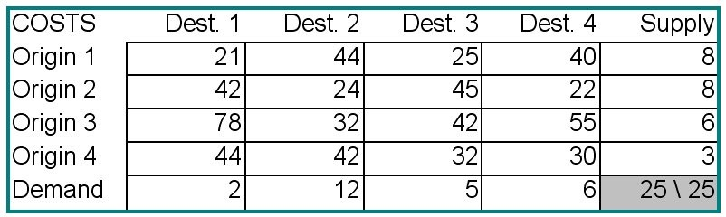
Answer: The optimal solution from Excel OM is in the table below.

Shipments | Dest 1 | Dest 2 | Dest 3 | Dest 4 | Row Total
Origin 1 | 2 | 0 | 5 | 1 | 8
Origin 2 | 0 | 6 | 0 | 2 | 8
Origin 3 | 0 | 6 | 0 | 0 | 6
Origin 4 | 0 | 0 | 0 | 3 | 3
Col. Total | 2 | 12 | 5 | 6 | 25 \ 25
Total Cost | 677

Diff: 3
Topic: The stepping-stone method
AACSB: Analytic Skills
Objective: LO-Module C-2
86) Find the minimum cost solution for the transportation problem detailed in the table below.

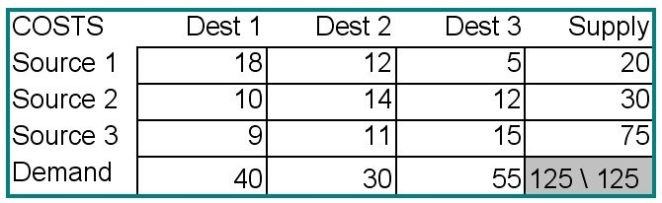
Before your solution can be implemented, you discover that the combination Source 3 — Destination 1 is unavailable, due to political turmoil in the country where Source 3 is located. Solve the revised problem. How much is cost increased by this complication?
Answer: The first solution is in the first table; cost of this solution is $1,225.

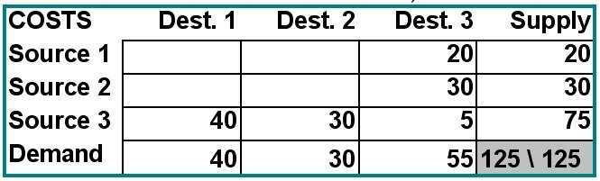
The revision is accomplished by assigning the prohibited cell a very high cost, such as $1,000. This solution appears in the second table; its cost is $1,535. The increase in cost is $310.

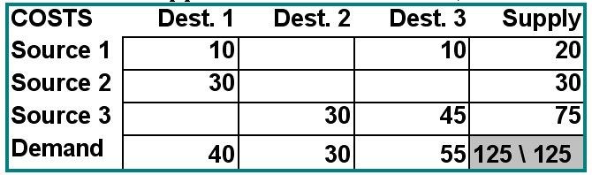
Diff: 3
Topic: The stepping-stone method
AACSB: Analytic Skills
Objective: LO-Module C-2
87) A firm has established a distribution network for the supply of a raw material critical to its manufacturing. Currently there are two origins for this raw material, which must be shipped to three manufacturing plants. The current network has the following characteristics:

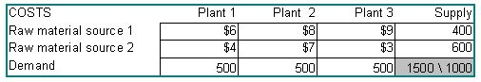
The firm has identified two potential sites for a third raw material source; these are identified as Candidate A and Candidate B. From A, the costs to ship would be $9 to Plant 1, $10 to Plant 2, and $12 to Plant 3. From B, these costs would be $11, $14, and $8. The new source, wherever it is located, will have a capacity of 500 units. Set up–but DO NOT SOLVE– this problem as though you were going to solve it with transportation problem software.
Answer: The setup requires two transportation problems, each with three sources.

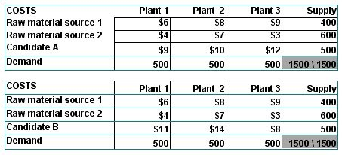
Diff: 2
Topic: Transportation modeling
AACSB: Analytic Skills
Objective: no LO

88) A firm has established a distribution network for the supply of a raw material critical to its manufacturing. Currently there are two origins for this raw material, which must be shipped to three manufacturing plants. The current network has the following characteristics:

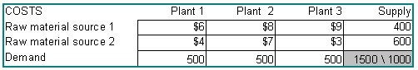
The firm has identified two potential sites for a third raw material source; these are identified as Candidate A and Candidate B. From A, the costs to ship would be $9 to Plant 1, $10 to Plant 2, and $12 to Plant 3. From B, these costs would be $11, $14, and $8. The new source, wherever it is located, will have a capacity of 500 units. Solve with the transportation method. Which site should be selected?
Answer: This problem requires two transportation problems, each with three sources.

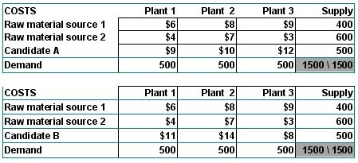
The solutions to these problems appear in the tables below.

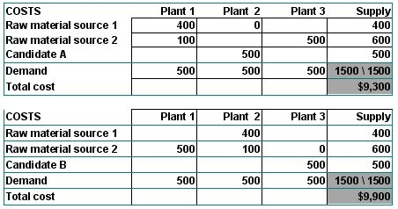
Candidate A should be selected.
Diff: 3
Topic: The stepping-stone method
AACSB: Analytic Skills
Objective: LO-Module C-2

89) A manufacturer of semiconductor "wafers" has been attempting to convert its operations to practices more in keeping with JIT principles. The firm is now paying much more attention to the transit time between one processing stage and the next. The plant has a somewhat haphazard pattern of machine locations, partly because the machines were purchased and installed at different times, partly from a shortage of floor space, and partly from previous experiments with work cells. The bottom line is this: there are four machines that perform a certain processing phase, and three machines that perform the next phase. All units of a large class of wafers go through these two phases. The table below displays the transit time, in minutes, from each machine of the first phase to each machine of the second. Machine 3 is not really 100 minutes away from machine B; the company has prohibited that combination because of quality problems associated with that specific pairing. Supply and demand quantities are in wafers processed per week. Develop a transit time minimizing solution for this firm. What is the total transit time of this solution? Which machines are fully utilized? Which machines have some capacity unused or requirements unfilled? Was the prohibition on the 3-B combination honored?

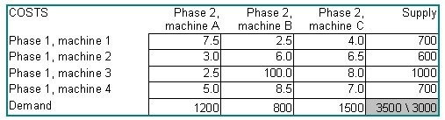
Answer: The solution appears in the software-generated table below. A dummy Phase 1 machine has been added because there is not perfect balance in the capacities of these two phases. The "cost" of this solution is a total transit time of 13,000 minutes per week. The destination phase Machine C required 1500 wafers, but got only 1000. All other machines in both phases are fully utilized. Yes, the quantity transferred from machine 3 to machine B is zero.

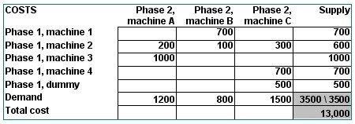
Diff: 3
Topic: The stepping-stone method
AACSB: Analytic Skills
Objective: LO-Module C-2

90) A transportation model's optimal solution uses no more than 8% of cells and has 100 sources. Find the number of destinations.
Answer: First develop equations for the number of used cells and the total number of cells. Then use the ratio given to solve for the number of destinations, assigned as variable X below.
99+X= number of cells used, 100X = total number of cells, (99+X)/100X = .08 thus X=14.14 = 14 destinations.
Diff: 2
Topic: Special issues in modeling
AACSB: Analytic Skills
Objective: LO-Module C-4
91) Given the following feasible solution determine if the problem is degenerate and then find the optimal solution and its cost. Assume that capacity for source A is 10 and 30 for source B. Destination A demands 10 units while destination B demands 30 units. Cost of shipping per unit is given as AA ($4), AB ($1), BA ($3), and BB ($2).

 | Destination A | Destination B
Source A | 10
Source B |  | 30

Answer: The number of cells used should be 4-1 = 3, however only 2 cells are used. Thus the problem is degenerate. Students may then place a zero in either empty cell and proceed with the stepping-stone method to find an optimal solution of

 | Destination A | Destination B
Source A |  | 10
Source B | 10 | 20

This solution has a total cost of 10*3+10*1+20*2= $80 (compared to $100 from the initial solution).
Diff: 2
Topic: Special issues in modeling
AACSB: Analytic Skills
Objective: LO-Module C-2 and LO4

92) Source A has capacity of 15, Source B has capacity of 30, Destination 1 has demand of 5 and Destination 2 has demand of 20. Fill in the following table with the correct initial solution for a Northwest-corner method approach.

 | Destination 1 | Destination 2 | Dummy Destination
Source A | 5 | 10
Source B |  | 10 | 20

Answer: Students should realize the need for a dummy destination with a demand of 20, however space should be left on the chart to place a dummy source so that students must make the distinction.
Diff: 2
Topic: Special issues in modeling
AACSB: Analytic Skills
Objective: LO-Module C-1 and LO3

93) A transportation model uses only 5% of its cells. If the number of destinations is 1000, determine the number of sources in the model.
Answer: Number of Cells is 1000X, number of used cells is 999+X, where X is the number of sources. Solving (99+x)/(1000X)=.05 yields X=20.4 = 20 sources.
Diff: 2
Topic: Special issues in modeling
AACSB: Analytic Skills
Objective: LO-Module C-4
94) A transportation model uses at least 10 sources and 100 destinations. If the ratio of sources to destinations remains constant, does the maximum % of cells used by the optimum solution remain constant? Why or why not?
Answer: Students should approach this problem in one of two ways. The first is to simply check values such as 10-100 and 20-200. The % of cells for each of these are 10.9% and 5.5%. Thus the maximum % of cells used by the optimum solution does not remain constant. For a complete answer students should solve for the % of cells used and analyze this function. Setting X as the number of sources the number of destinations becomes 10X. Thus the maximum number of cells used is 11X-1 while the maximum number of cells is 10X^2. Thus the % utilization is 100*(11X-1)/(10X^2) or 110/X-10/X^2. Since this function is not constant for values of X greater than 10 (at least 10 sources from the given information) the maximum % of cells involved in the optimum solution is not constant for a constant ratio of sources to destinations. Students may also notice that the limit of the function is 0 as X approaches infinity, yielding insight that as the number of sources and destinations increase, even when increases are proportional, the maximum number of cells used for the optimum solution declines.
Diff: 3
Topic: Special issues in modeling
AACSB: Analytic Skills
Objective: LO-Module C-4

